Project Design Phase-II
Technology Stack (Architecture & Stack)

Date | 06 October 2026
Team ID | 6aba1145538da4003d631644
Project Name | Auto Ticket Classification using Flow
Maximum Marks | 4 Marks

Technical Architecture:
The Deliverable shall include the architectural diagram as below and the information as per the table1 & table 2
Architecture: Auto ticket classification for the school IT helpdesk using ServiceNow Flow Designer
Platform: ServiceNow (Flow Designer, Incident Management)
Guidelines:
Include all the processes (As an application logic / Technology Block)
Provide infrastructural demarcation (Local / Cloud)
Indicate external interfaces (third party API’s etc.)
Indicate Data Storage components / services
Indicate interface to machine learning models (if applicable)
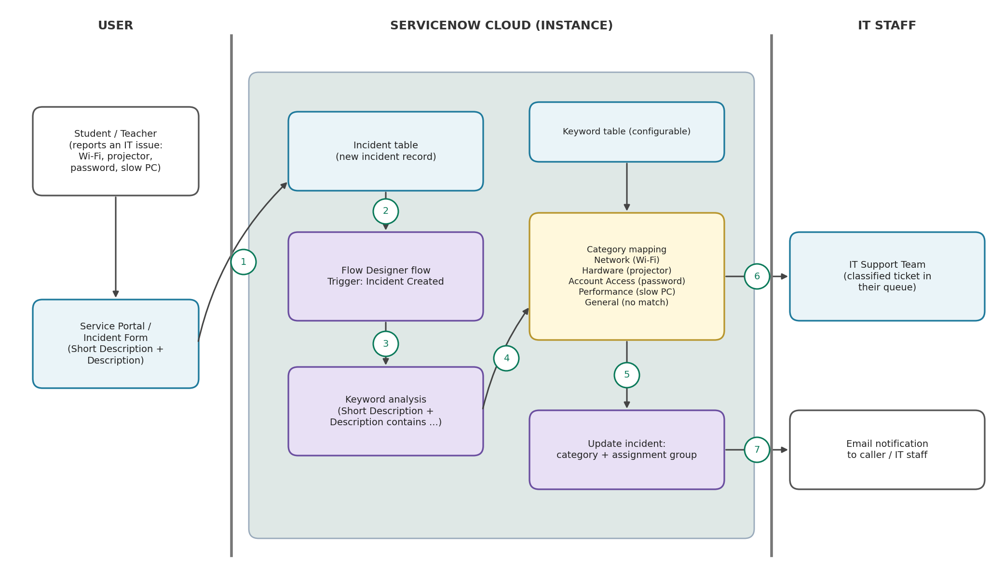

Table-1 : Components & Technologies:
S.No | Component | Description | Technology
 | User Interface | Students and teachers report issues (Wi-Fi, projector, password, slow computer) through a web form;  IT staff view the classified incidents in the ServiceNow incident list. | ServiceNow Service Portal / Incident form (HTML, CSS, JavaScript)
 | Application Logic-1 | Flow triggered automatically when a new incident is created. | ServiceNow Flow Designer (Trigger: Incident Created)
 | Application Logic-2 | Analyzes keywords in the Short Description and Description fields and maps them to a category (Network, Hardware, Account Access, Performance, General). | Flow Designer conditions (contains keyword) / JavaScript script step
 | Application Logic-3 | Updates the incident with the category and assignment group, and notifies the caller and IT staff. | Flow Designer Update Record action, ServiceNow Notifications
 | Database | Incident table stores short description, description, category and assignment group; a custom keyword table stores keyword-to-category rules. | ServiceNow Now Platform relational database (Incident table, custom keyword table)
 | Cloud Database | Database service hosted on the ServiceNow cloud instance. | ServiceNow cloud instance (Personal Developer Instance)
 | File Storage | Optional screenshots or error files attached to an incident. | ServiceNow Attachments (sys_attachment)
 | External API-1 | Email notification to inform the caller and IT staff once the ticket is classified. | ServiceNow Email Notifications (SMTP)
 | External API-2 | Not used in the current scope. Chat tools can be integrated later through the ServiceNow REST API. | ServiceNow REST API (future scope)
 | Machine Learning Model | Not used. Classification is rule-based keyword matching; an ML model can be added later to handle new or unclear wording. | Rule-based keyword matching (ServiceNow Predictive Intelligence as future scope)
 | Infrastructure (Server / Cloud) | Application deployment on ServiceNow Cloud  Local Server Configuration: Not required; accessed through a web browser.  Cloud Server Configuration: ServiceNow instance with Flow Designer and Incident Management enabled. | ServiceNow Cloud (PaaS)

Table-2: Application Characteristics:
S.No | Characteristics | Description | Technology
 | Open-Source Frameworks | Open-source front-end libraries used by the Service Portal for the user interface. | AngularJS, Bootstrap, JavaScript
 | Security Implementations | Role-based access control, user authentication and encrypted communication; flow actions are logged for audit. | ServiceNow ACLs and roles, SSO / login, HTTPS (TLS)
 | Scalable Architecture | Multi-tier cloud platform; new categories or keywords can be added in the keyword table without changing the flow. | ServiceNow multi-tier cloud platform, Flow Designer, keyword table
 | Availability | The application runs on the ServiceNow managed cloud, so no local servers are needed for the helpdesk to stay available. | ServiceNow cloud infrastructure (managed availability)
 | Performance | The flow runs automatically on incident creation and uses simple keyword conditions, so classification happens without manual review. | Flow Designer, Flow execution history

References:
https://c4model.com/
https://developer.ibm.com/patterns/online-order-processing-system-during-pandemic/
https://www.ibm.com/cloud/architecture
https://aws.amazon.com/architecture
https://medium.com/the-internal-startup/how-to-draw-useful-technical-architecture-diagrams-2d20c9fda90d

